Rigorous and Relevant Student Performances
 | Title |  | 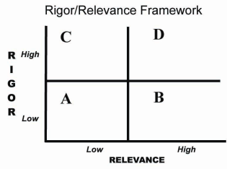
 | Insert Title Here
Focus |  | Identify subject, course, unit and students to be served
Click here to write enter information

Student Learning |  | Identify concepts, knowledge, skills and behaviors
Click here to write enter information

Performance Task |  | Describe the student work used to demonstrate learning
Click here to write enter information

Standards |  | Link this lesson to state or national standards or International Center Essential Skills
Click here to write enter information

Scoring Guide |  | Attach copies of scoring guide or rubric to assess performance task
Exemplars (optional) |  | Attach copies, descriptions or images of exemplary student work
Lesson Plan (optional |  | Attach copies of teacher procedures and student activities

